**Task#1:** Create a program which contains a textfield and a button and on click of the button method is called in which the number entered in textfield is multiplied by ‘3’ and the result generated is displayed using toast message.

**Solution:**

**XML:**

<?xml version="1.0" encoding="utf-8"?>  
<LinearLayout xmlns:android="http://schemas.android.com/apk/res/android"  
 xmlns:app="http://schemas.android.com/apk/res-auto"  
 xmlns:tools="http://schemas.android.com/tools"  
 android:layout_width="match_parent"  
 android:layout_height="match_parent"  
 android:orientation="vertical"  
 android:weightSum="10"  
 tools:context=".MainActivity">  
  
 <TextView  
 android:layout_width="match_parent"  
 android:layout_height="wrap_content"  
 android:text="Lab#2!"  
 android:textAlignment="center"  
 android:textSize="30dp" />  
 <TextView  
 android:layout_width="match_parent"  
 android:layout_height="wrap_content"  
 android:text="(Khizar Hayat)"  
 android:textAlignment="center"  
 android:textSize="20dp" />  
 <TextView  
 android:layout_width="match_parent"  
 android:layout_height="wrap_content"  
 android:text=""  
 android:layout_weight="2"  
 android:textAlignment="center"  
 android:textSize="20dp" />  
  
 <EditText  
 android:id="@+id/text_view"  
 android:layout_width="match_parent"  
 android:layout_height="wrap_content"  
 android:hint="Enter any Integer"  
 android:textSize="20dp" />  
  
 <Button  
 android:id="@+id/check_button"  
 android:layout_width="wrap_content"  
 android:layout_height="wrap_content"  
 android:layout_gravity="center"  
 android:text="Check"  
 android:textSize="20dp" />  
   
</LinearLayout>

**JAVA:**

public class MainActivity extends AppCompatActivity {  
  
 Button btn;  
 TextView txt;  
  
 int input, result, result2;  
  
 @Override  
 protected void onCreate(Bundle savedInstanceState) {  
 super.onCreate(savedInstanceState);  
 setContentView(R.layout.activity_main);  
  
 txt =(TextView) findViewById(R.id.text_view);  
 btn =(Button) findViewById(R.id.check_button);  
  
 btn.setOnClickListener(new View.OnClickListener() {  
 @Override  
  
 public void onClick(View v) {  
  
 try {  
 input = Integer.parseInt(txt.getText().toString());  
 result = input * 3;  
 Toast.makeText(MainActivity.this, "Result: " + result, Toast.LENGTH_SHORT).show();  
 result2 = input/0;  
 Toast.makeText(MainActivity.this, "Result: " + result, Toast.LENGTH_SHORT);  
  
 }  
 catch (Exception e){  
 if(result2 != 0){  
 Log.i("Exception Information","Divided by zero");  
 }  
 else {  
 Log.e("Exception Error", "Cannot divide by zero");  
 }  
 }  
 }  
 });  
 }  
}

**Output:**

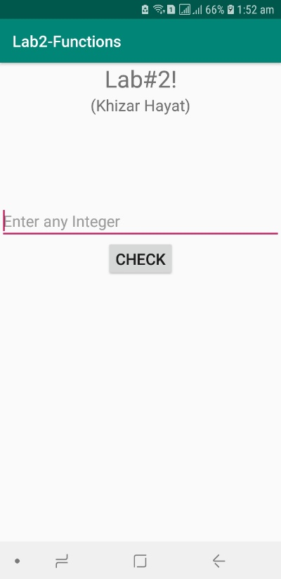

**Task#2:** Also call a function that will divide the number entered in textfield by 0. If successfully executed, the log should show info(log.i) else should show the exception (log.e).[use try catch]

**Solution:**

Implemented in Task#1

**Output:**

